**AFNDKGEWI DEALERSHIP USER GUIDE**

**Database 431 Project**

**BY: Orazio Lentini**

**Krunal Intwala**

**December 17, 2012**

**AFNDKGEWI DEALERSHIP USER GUIDE**

**Contents:**

**Prefix**

* 1. System Requirements
  2. Entity-Relationship Design
  3. Relational Logical Database Design
  4. Application Program Design
  5. Design Decisions

**Create New Customer**

* 1. Creating New Customer

**Customer Car Purchase**

* 1. Inserting Customer Car Purchase
  2. Printing Receipt of Car Purchase

**Scheduling Service Appointment**

2.1Non-Dealership Customer

2.2 Dealership Customer

**Car Service**

3.1 Entering Car into Service

3.2 Printing Service Receipt

**Retrieving Sale Statistics**

4.1 Retrieving Sale Statistics

**APPENDIX**

5.1 Relational Instances

**Prefix**

* 1. **System Requirements**

1. Works on Windows XP, 2000, 2003, Vista, 7 and 8, Linux, and Unix.
2. Works with Internet Explorer, Firefox and Chrome browsers.
3. Requires Internet Connection.
4. **Entity-Relationship Design**

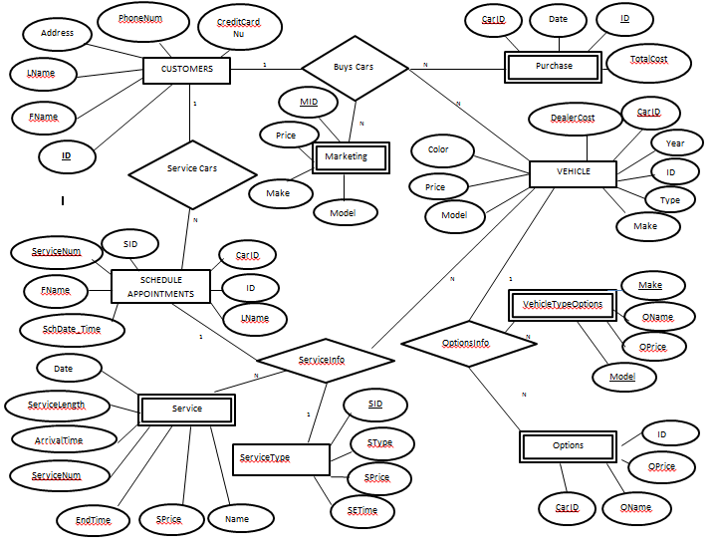

* 1. **Relational Logical Database Design**

**STEP 1: Primary Entities**

CUSTOMERS (ID, FirstName, LastName, Address, PhoneNum, CreditCardNum)

VEHICLE(CarID, ID, Make, Model, Year, Type, Color, Price, DealerCost)

SCHEDULE APPOINTMENT( ServiceNum, FirstName, LastName, Sch_Date_Time, SID, CarID, ID)

SERVICETYPE(SID, SType, SPrice, SETime)

**STEP 2: Weak Entities**

PURCHASE(CarID, ID, Date, TotalCost)

VEHICLETYPE(Make, Model, OName, OPrice)

OPTIONS(ID, CarID, OName, Oprice)

SERVICE(ServiceNum, ServiceLength, Arrivaltime, Date, EndTime, SPrice, Sname)

**STEP 3: 1 TO 1 Relationship**

There is no one to one relationship.

**STEP 4: 1 TO N Relationship**

* CUSTOMERS to VEHICLE
  + A Customer can choose many Vehicles. (returning customers)
  + Primary Key (ID) from CUSTOMER
  + VEHICLE (CarID, ID, Make, Model, Year, Type, Color, Price, DealerCost)
* CUSTOMERS to PURCHASE
  + A Customer can purchase many Vehicles.
  + Primary Key (CarID) from VEHICLE
  + PURCHASE (CarID, ID, Date, TotalCost)
* VEHICLE to VEHICLETYPEOPTIONS
  + A Customer can choose the vehicle with many options.
  + VEHICLETYPEOPTIONS (Make, Model, OName, OPrice)
* VEHICLE to OPTIONS
  + A Customer can buy many options for their car.
  + Primary Key (CarID) from VEHICLE
  + OPTIONS (CarID, ID, OName, OPrice)
* CUSTOMERS to SCHEDULE_APPOINTMENTS
  + A Customer can schedule many appointments.
  + Primary Key (ID) from CUSTOMER
  + SCHEDULEAPPOINTMENTS(CarID,ID, ServiceNum, FirstName, LastName, Sch_Date_Time, SID)
* SCHEDULEAPPOINTMENTS to SERVICETYPE
  + In one scheduled appointment there could be many type of services that can be performed.
  + SERVICETYPE (SID, SType, SType, Sprice, SETime)
* CUSTOMER to MARKETING
  + A Customer can be marketed through specific model, make, or price range.
  + MARKETING (MID, Price, Make, Model)

**STEP 5: N TO M**

There is no many to many relationships.

**Final Set of Relationships:**

CUSTOMERS (ID, FirstName, LastName, Address, PhoneNum, CreditCardNum)

VEHICLE(CarID, ID, Make, Model, Year, Type, Color, Price, DealerCost)

SCHEDULEAPPOINTMENTS( ServiceNum, FirstName, LastName, Sch_Date_Time, SID, CarID, ID)

SERVICETYPE(SID, SType, SPrice, SETime)

PURCHASE(CarID, ID, Date, TotalCost)

VEHICLETYPE(Make, Model, OName, OPrice)

OPTIONS(ID, CarID, OName, Oprice)

SERVICE(ServiceNum, ServiceLength, Arrivaltime, Date, EndTime, SPrice, Sname)

* 1. **Application Program Design**

Services Available

Options Available

Car Prices

Print Receipt

Car Purchase

Statistic Form

Arrival Form

Service Form

Scheduled Appointment

Car Appointment Arrival

Check Scheduled Appointments

Car Information Form

Non Dealership Customer

Dealership Customer

Service Receipt

New Customer Form

Create New Customer

Car Sale

Sale Statistics

Service Appointment

Schedule Service Appointment

HOME-PAGE

* 1. **Design Decisions**

1. **Home Page has 5 links: To Accommodate Services Provided by Dealership**
   1. Create New Customers, Car Sale, Schedule Service Appointment, Service Appointment and Sales Statistics
2. **Create New Customer – Creates a New Customer by New Customer Form**
   1. New Customer Form – Takes in Customers information: First Name, Last Name, Address, PhoneNum , and CreditCardNum.
   2. ID is automatically assigned to the Customer and it is UNIQUE
3. **Car Sale– has a link to Purchase a Car and Print Receipt**
   1. Car Purchase Form – Takes in Vehicle and some Customer Information: First Name, Last Name, Make Model, Color, Year, DealerCost, Type, Option Name, and Option Price.
      1. Dealer Cost and Type comes from a Clickable link Table that has all the vehicle dealership offers with their respective prices
      2. Option Name and Option Price comes from Table VEHICLETYPEOPTION which takes in Make and Model then lists all the available options
   2. Print Receipt takes in FirstName, LastName and Date to create an invoice for the customer. It needs to take FirstName and LastName again is because it is easier to print the bill again. Date is used because the customer could be purchasing another car at the dealership.
4. **Schedule Service Appointment- has two links for new customer and existing customer**
   1. New Customer has a link at the top that opens another tab on the browser to create new customer , then the car dealers can enter the information
   2. Both links have similar form – Both have FirstName, LastName, Make, Model, Year, Make Appointment and Service Type
      1. Make Appointment – needs to check availability from clickable link Check Availability which shows table of appointments for specific date.
      2. Service Type – need to check services available at the dealership by clickable link Service Available.
5. **Service Appointment – has three links Check Scheduled Appointments, Car Appointment Arrival and Service Receipt**
   1. Check Scheduled Appointments is table Check Availability which was used to make appointment – this table has name of customers and the time of appointment – this is to check if the customer has made the Appointment when he/she arrives.
   2. Car Appointment Arrival – has form that takes FirstName, LastName, Make, Model, Year and Arrival Time to make sure it is the scheduled car for maintenance.
   3. Service Receipt takes in FirstName, LastName and Date to create an invoice for the customer. It needs to take FirstName and LastName again is because it is easier to print the bill again. Date is used because the customer could be getting another service at the dealership.
6. **Sales Statistics – has a form to put two dates**
   1. It uses two dates and creates a table that shows number of cars sold and the profit made by Specific make, model and year

**Create New Customer**

* 1. **Creating New Customer**

When a new customer comes into the dealership to either purchase a car or schedule his/her car for an appointment their information must be entered into the system.

1. To do this, click on the link: 
2. Next enter the new customer information. Fill out form completely.

PhoneNum: (XXX)-XXX-XXXX

Credit Card Number: XXXX-XXXX-XXXX-XXX

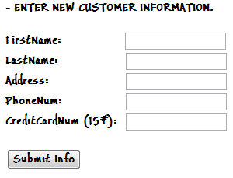

1. Press Submit Info button to enter the customer’s information into the system.

After their information is stored use appropriate links:

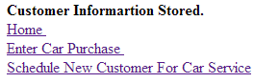

- Go Dealership Homepage



- Go directly to new customers car purchase form. (See 1.2 Inserting Customer Car Purchase)



- Go directly to schedule service appointment, Non-Dealership Customer form. (See 2.1Non-Dealership Customer) 

**Customer Car Purchase**

* 1. **Inserting Customer Car Purchase**

When a customer wants to purchases a car we have to store his/her car information before a bill is printed.

1. Click on the link: Then click: 

(If you clicked on link after customer info was stored you will be directed immediately to the car purchase vehicle form.)

1. Enter the customer’s First Name, Last Name and information of their Vehicle Purchase

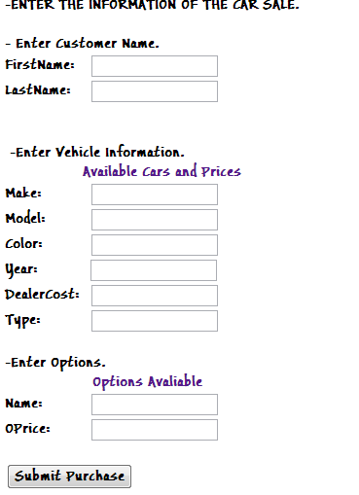

1. To get the prices of the car click on the link. It will open a new tab. It will display the available cars and prices. Then input the information into vehicle information box.

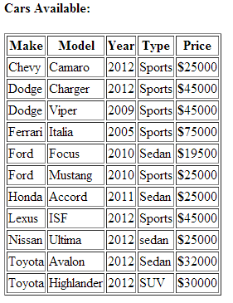

1. To find options available for the specific car the customer is purchasing click link: This will open a new tab where you enter the Make and Model of the car the customer is purchasing.

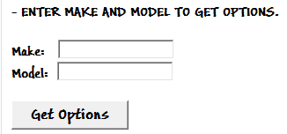

1. Press Get Options, and enter the Option Name and Price into the form according to the option that the customer wants (if they don’t want any leave the spaces blank).
2. Press to enter information into the system.

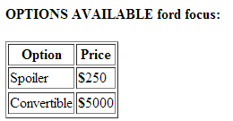

1. From here you will be able to click the link, or you may click the link to go directly to printing a receipt for the customer.
   1. **Printing Receipt of Car Purchase**
2. Once in the print receipt form enter the First Name, Last Name, and Date of Purchase.

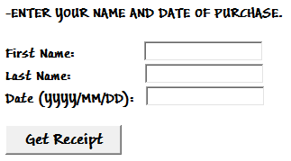

1. After you enter all the information press and the customers receipt will be displayed and ready to print.
2. Press the CTRL button and P at the same time to print the receipt to hand to the customer.
3. After the receipt is printed click the link  to return to the dealership homepage.

**Scheduling Service Appointment**

**2.1 Non-Dealership Customer**

There are two ways to get to the form to schedule an appointment for a Non dealership customer.

1. If the customer is a returning customer but the car they want for service wasn’t purchased from the dealership click on the link: (This will be at main page) Then click:
2. The other way to get to the schedule service form for non-dealership customers is, if the customer is a new customer and is just created (See 1.1 Creating New Customer) the customer, click on the link: and it will go directly to the scheduling appointment form.

3 If the customer’s information has not been stored into the system click: and you will be directed to the new customer information page. (see 1.1 Creating New Customer Steps 1-3 )

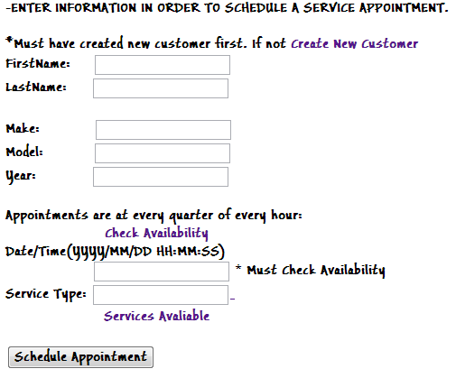

4 The form will look like this. When on this page, enter the First Name and Last Name of the Customer.

1. Then Enter the Make, Model, and Year of the car.
2. When scheduling appointments, appointments can only be scheduled at ever quarter of a hour (00, 15, 30, 45).
3. Enter the date and time of the preferred appointment in the format (YYYY/MM/DD HH:MM:SS)
4. To check availability of the desired time, click the link: which will open a new tab.
5. In the form enter the desired date and click: 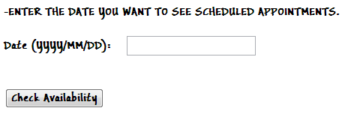
6. A list of all appointments will be displayed. If the desired time is available, continue to fill out the form. If time not available ask the customer for a different appointment time.

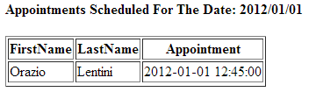

1. To finish scheduling the appointment, click the link: which will open in a new tab.
2. It will display the SID, and Name of each service.

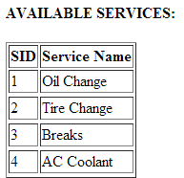

1. Record the SID of the service the customers wants on his/her car and enter that number in the box.
2. To schedule the appointment press: If the desired Date and Time is available it will say: “**Appointment Set.**” If the desired date /and or time is not available: “**Desired Date and or Time NOT AVAILABLE. Please Choose Another.**” will be displayed.
3. If the Date and or Time is not available go back by pressing the back arrow on the browser and enter a different date and or time.
4. Once an appointment is set, press the link to return to the dealership homepage.

**2.2 Dealership Customer**

1 To schedule an appointment for a customer whose car has been purchased at the Dealership click the link: (which is found at the dealership homepage). Then click: 

1. Once you click the link you will be sent to the scheduling appointment form. 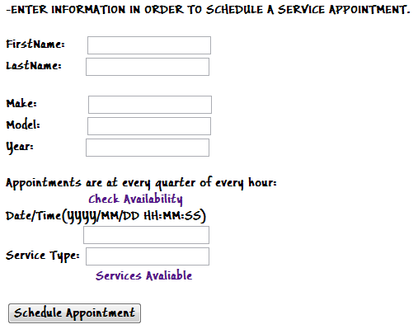

To schedule appointment follow steps 4-16 in section (**2.1 Non-Dealership Customer**)

**Car Service**

**3.1** **Check Scheduled Appointment**

When a customer comes in to drop off his/her car into service, you must check if they have scheduled an appointment.

1. To check if the person has scheduled an appointment click the link: (found on the dealership website). Then click: 
2. Once clicked enter the date of the scheduled service (Date Format: YYYY/MM/DD)

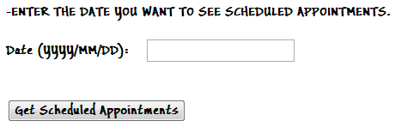

1. Once date is entered press: 
2. If no appointments shows with the customer’s Name, they have not scheduled an appointment. Click the link:  to return to the dealership homepage.
3. If the customer’s name appears click the link: to go directly to the car arrival form. (For instructions see 3.2 Entering Car into Service)

**3.2 Entering Car into Service**

When the customer of a scheduled appointment arrives some information has to be stored.

1 To store the information click the link: (found on the dealership website). Then click:

1. Once clicked the arrival form will show up.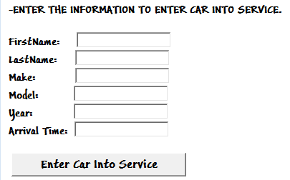
2. Enter the information First Name, Last Name of the customer. Then enter the Make, Model, Year and Arrival Time. The format for Time: HH:MM:SS
3. After information has been filled in, press:When the car is submitted into service it will say, “**Service Will Be Approximately:** (Estimated time of service)**”**
4. Now press the link to return to the dealership website.
   1. **Printing Service Receipt**

Once the scheduled service of a customer’s car is completed a receipt is to be given to the customer.

1. While on the Dealership homepage click:  Then click: 
2. Once service receipt is click the receipt form will come up. 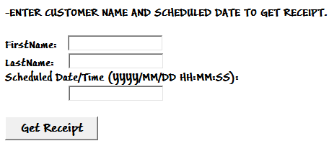
3. Enter the First Name, Last Name, and the Scheduled Date/Time that the customer has made. Format for Date/Time (YYYY/MM/DD HH:MM:SS)
4. Once the information is entered press: and a detailed receipt of the service/s perfomed on the customers car will be displayed.
5. Press the CTRL button and P at the same time to print the receipt to hand to the customer.
6. After the receipt is printed click the linkto return to the dealership homepage.

**Retrieving Sale Statistics**

**4.1 Retrieving Sale Statistics**

1 To retrieve the sale statics of the dealership during a certain time, while on the dealership homepage click on the link: 

2 Once clicked it will go to the sale statistics form where you input two dates to get the sale statistics of.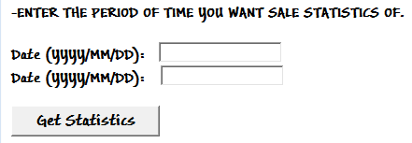

1. Fill in the two dates that you want the statistics of. Date format (YYYY/MM/DD) Then press 
2. Once pressed, the system will output the number of cars sold. Number of cars of the same Make, Model, Year and Profit made for each car.

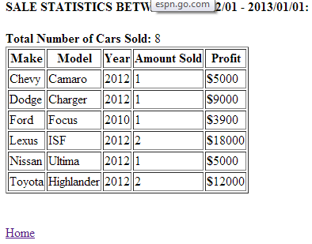

1. After analyzing the statistics press the link: to return to the dealership homepage.

**APPENDIX**

**5.1 RELATIONAL INSTANCES**

**CUSTOMER**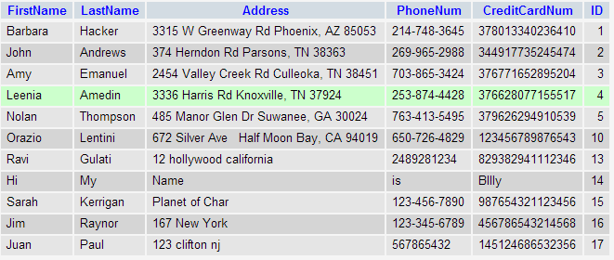

**VEHICLE**

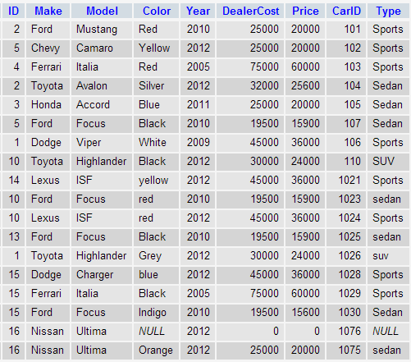

**VEHICLETYPEOPTIONS**

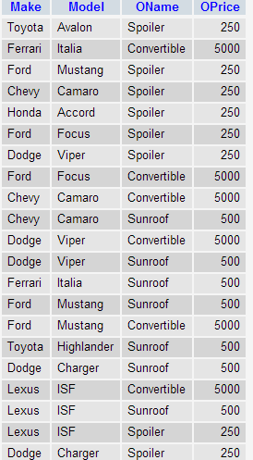

**OPTIONS**

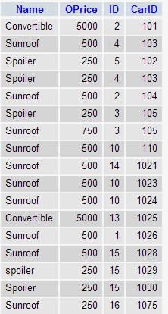

**PURCHASE**

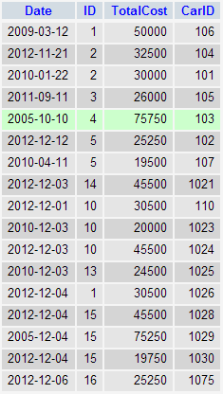

**MARKETING**

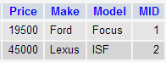

**SCHEDULEAPPOINTMENT**

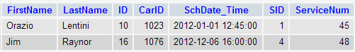

**SERVICE**



**SERVICETYPE**

